**Vanier College**

**Computer Science Department**

**Final Project Document**

**Student Name: Yao Wu & Zheng Xue**

### Student Id: 2395031 & 2395035

**Teacher: Kawser Wazed Nafi**

**420-942 VA: Application Development 1 (Desktop) (Sect.01222)**

**College Library Management System**

The College Library Management System (CLMS) represents a comprehensive solution designed to enhance the efficiency and functionality of the library within our educational institution. The system is bifurcated into two primary components: the User Interface and the Administrator Interface. These interfaces collectively serve the diverse needs of students, faculty and staff, as well as administrators tasked with overseeing the library's operations. The User Interface empowers users with the ability to register and log in securely, search for books, facilitate borrowing and return transactions, renew borrowed items, and modify personal information. On the other hand, the Administrator Interface provides robust tools for managing the library's book inventory, enabling the addition and deletion of books, as well as the ability to query and manage user accounts.

**1. Project Scope:**

The College Library Management System (CLMS) is designed to cater to the needs of students, faculty and staff, and administrators within an educational institution. The primary objective is to provide an efficient and streamlined process for borrowing books from the library while offering administrative tools for effective management. The system aims to benefit all stakeholders involved in the library ecosystem.

Users:

Students, Faculty and Staffs

They are the primary beneficiaries of the system, as they can use it to query the books, borrow, return and renew books. Also, they can register, login and modify their information.

Administrator:

Administrative staff can use the system to manage the circulation of books, keep an inventory of available resources, and assist users in their queries. The administrator has overarching control and responsibility for the entire library system. They can manage user accounts, update the catalog.

Potential Clients:

The College Library Management System is well-suited for educational institutions such as colleges and universities. Institutions with a substantial student and faculty population, along with a diverse collection of academic resources, stand to benefit the most from this system.

Potential clients include:

Vanier College, with its focus on academic excellence, can benefit from the CLMS to streamline library operations and offer an improved experience to students and faculty.

1. **Project Functionalities:**

Our College Library Management System (CLMS) boasts a range of functionalities tailored to meet the diverse needs of users and administrators, creating a seamless and efficient library experience. Below is a comprehensive overview of the key functionalities implemented in the project, accompanied by screenshots to illustrate the user interface.

**Main Window**

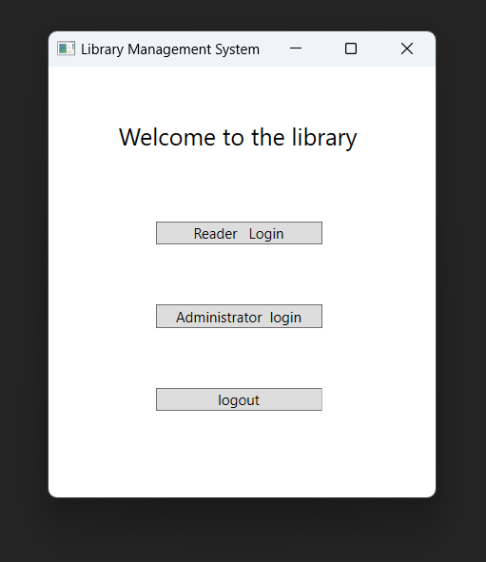

This is the entrance to the APP, the initial interface, which is divided into three branches: user login, administrator login, and logout.

**User Interface:**

1. **User login**

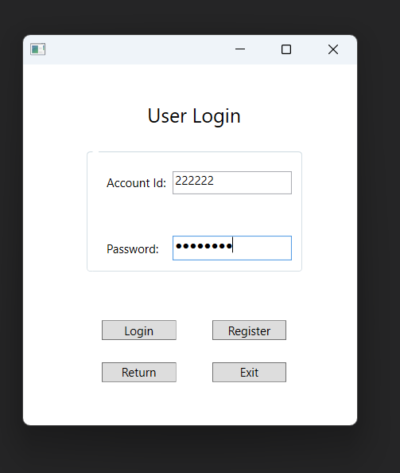

user input account and password to login to the library system

1. **User operation interface**

Modify information:

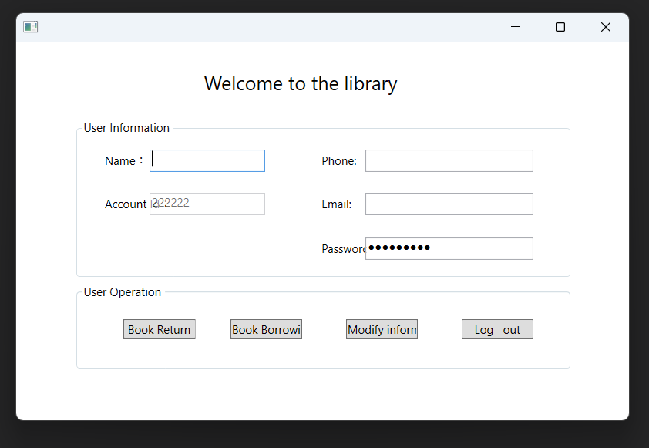

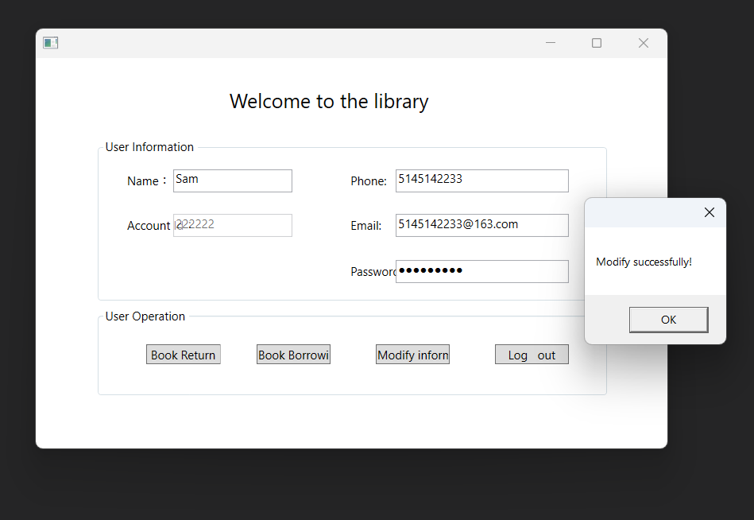

Modify the user information, and database data changes accordingly.



**3. user book return interface**

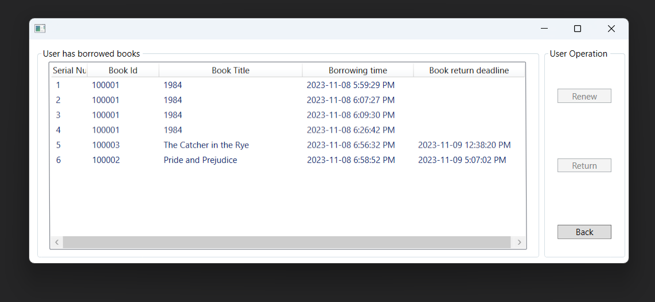

List all books borrowed by the user ( account id:222222 ) ) who borrows

1. **user return the book**

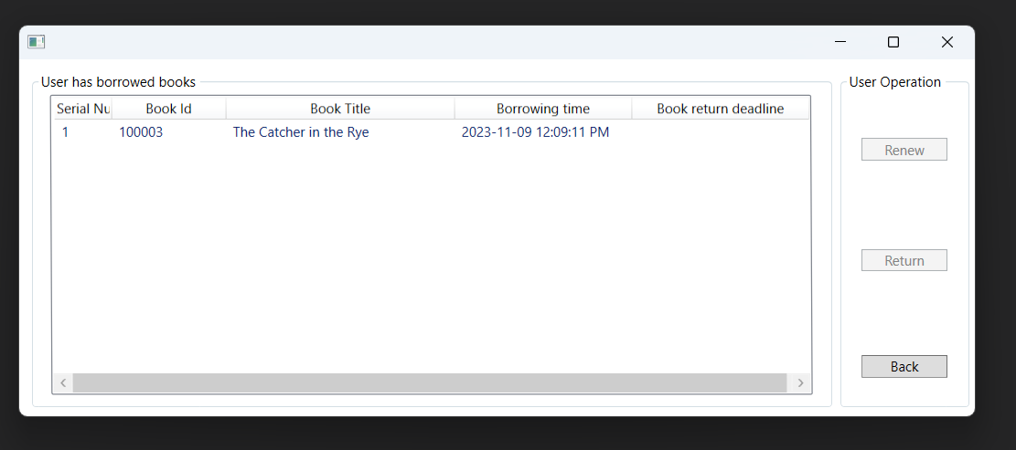

This is user (account id: 999999)

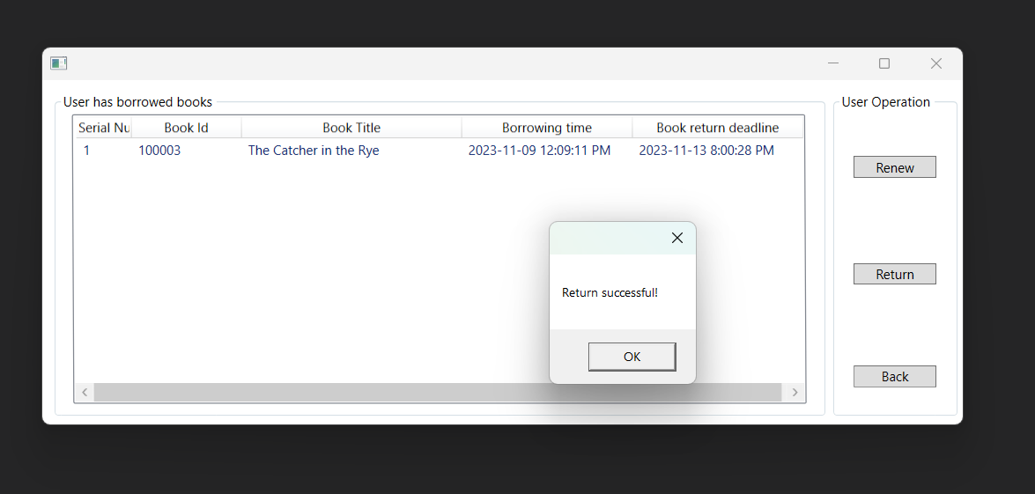

When we return, update the database the filed book return time.

1. **user books borrow interface**

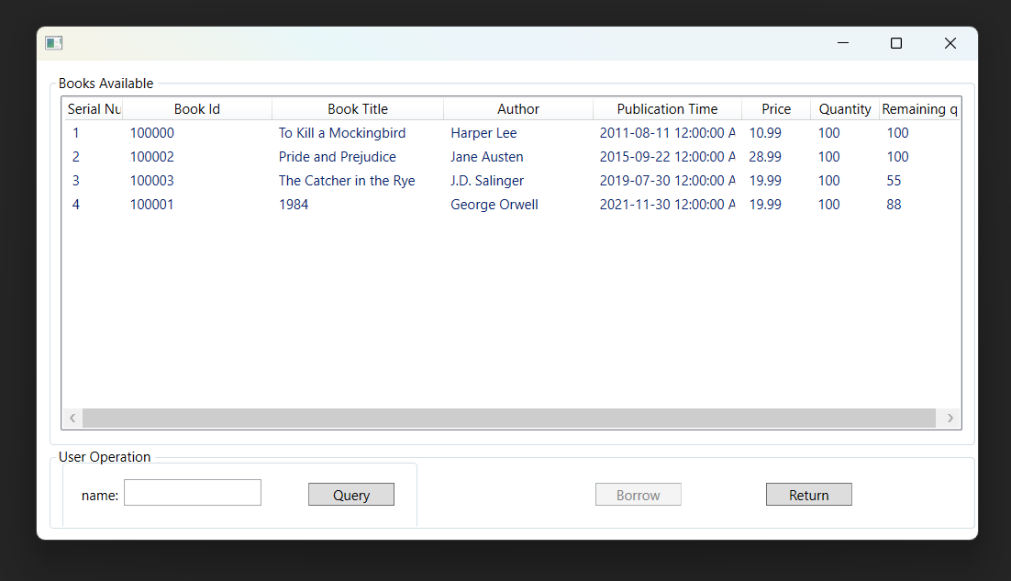

**5 query books**

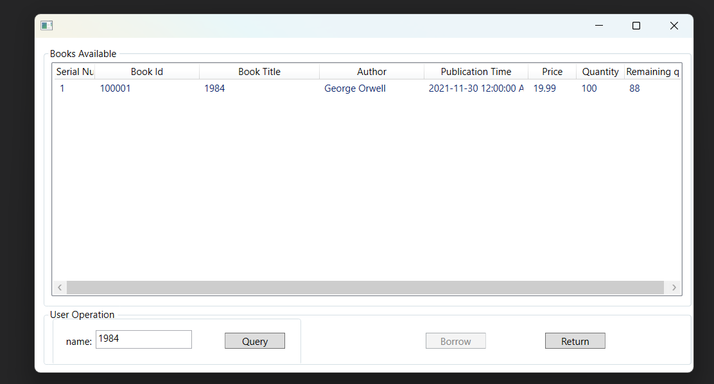

**6.Borrow book**

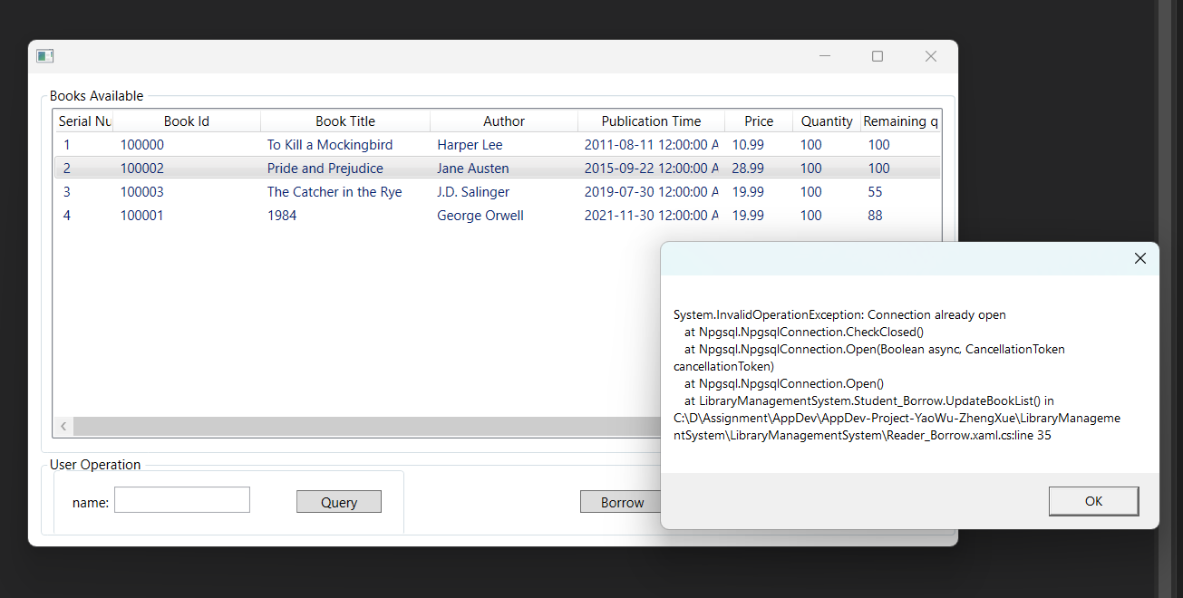

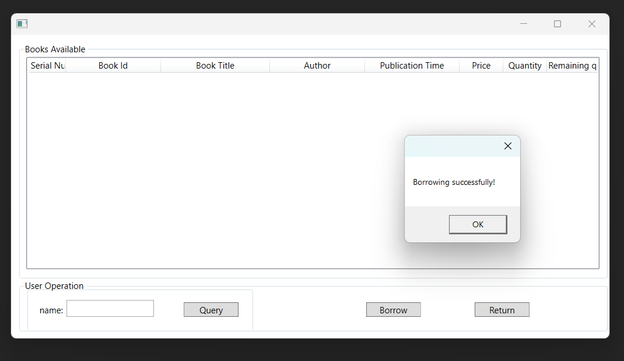

Successfully borrowed the book "Pride and Prejudice", At the same time, the database is updated.



**Administrator interface**

1. **Administrator login**

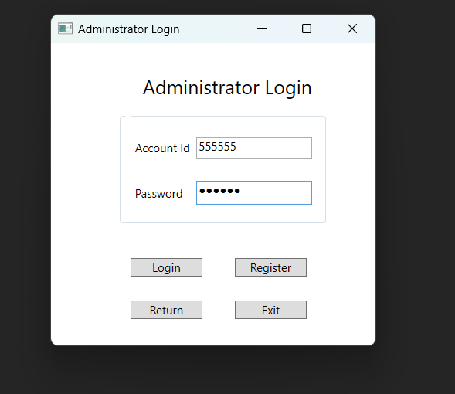

1. **Administrator operation interface**

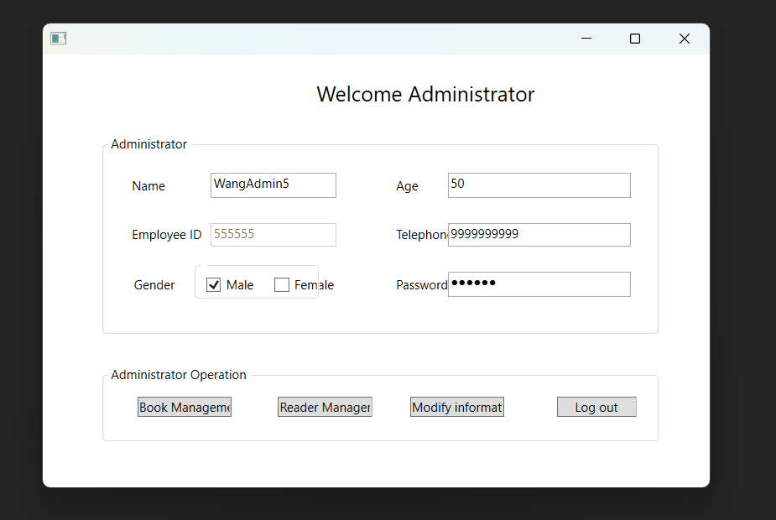

This window, administrator can do operation : book management, reader management and modify information.

1. **modify the administrator information**

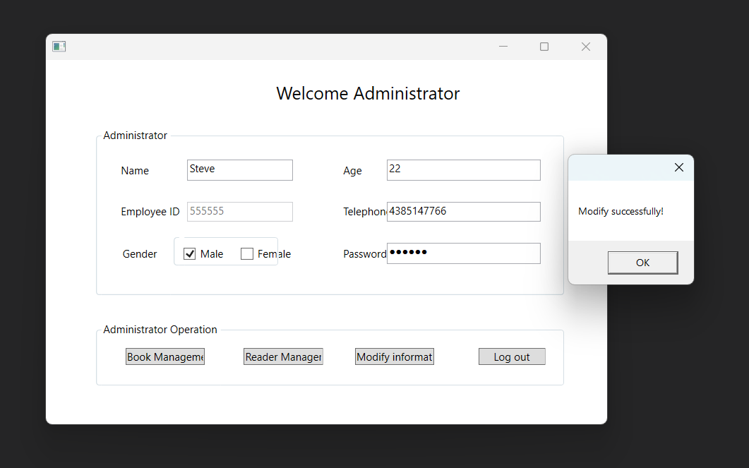

Update database information accordingly



**4.Book management interface**

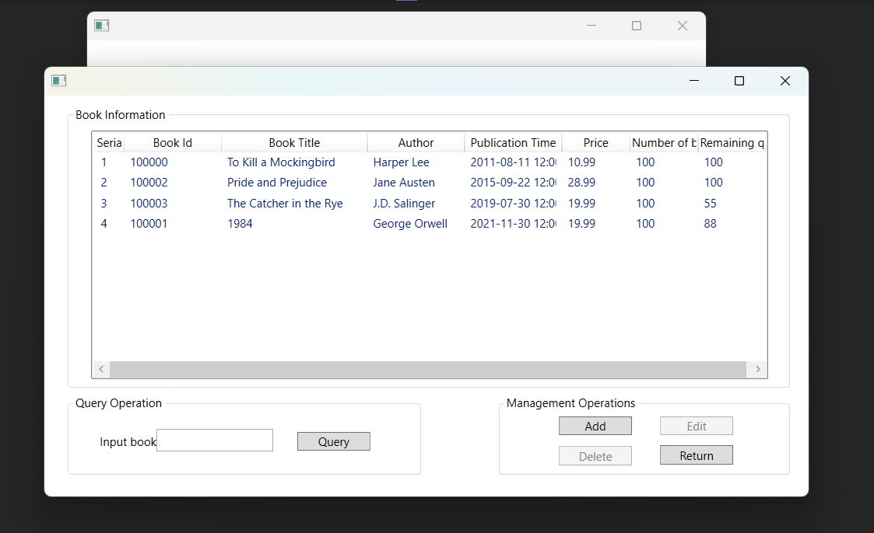

1. **add book interface**

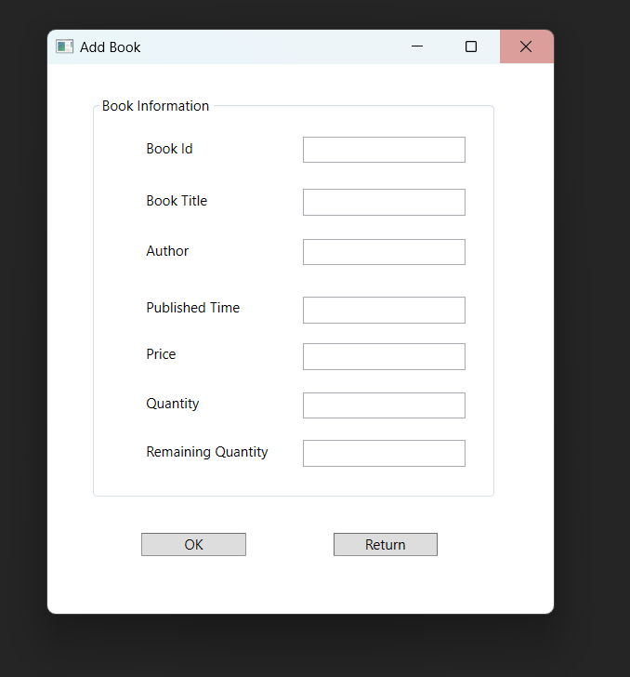

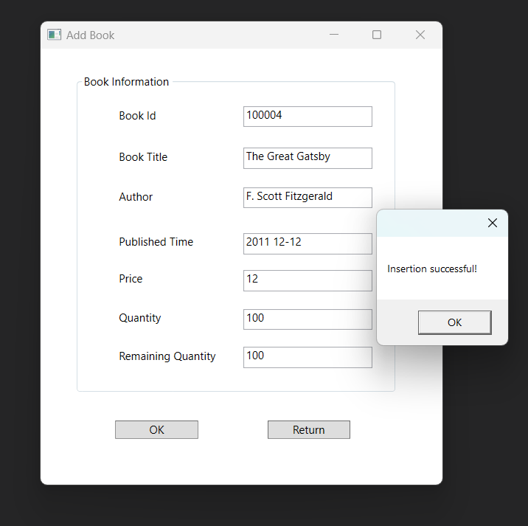

**A book was successfully added and the database was updated accordingly.**



1. **list all books**

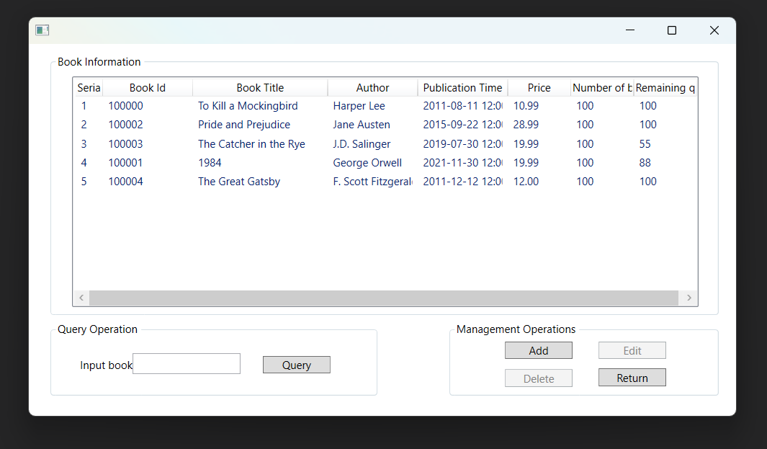

1. **Delete a book**

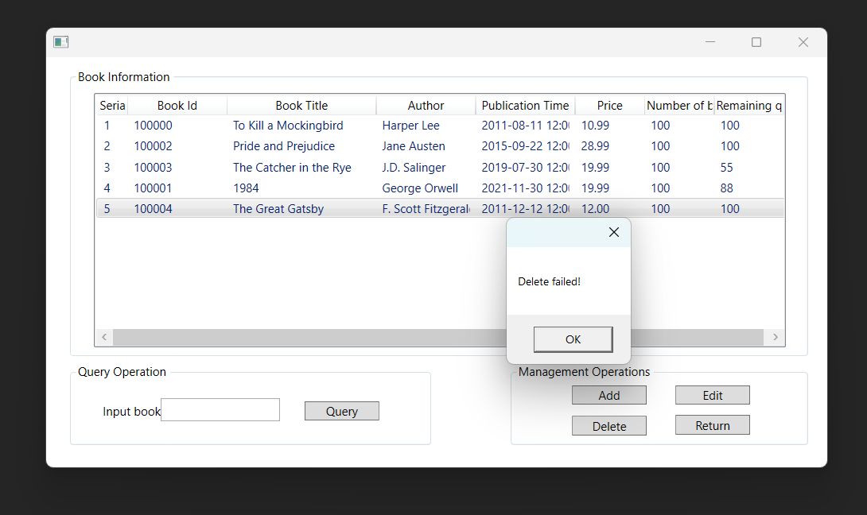

1. **Manage users**

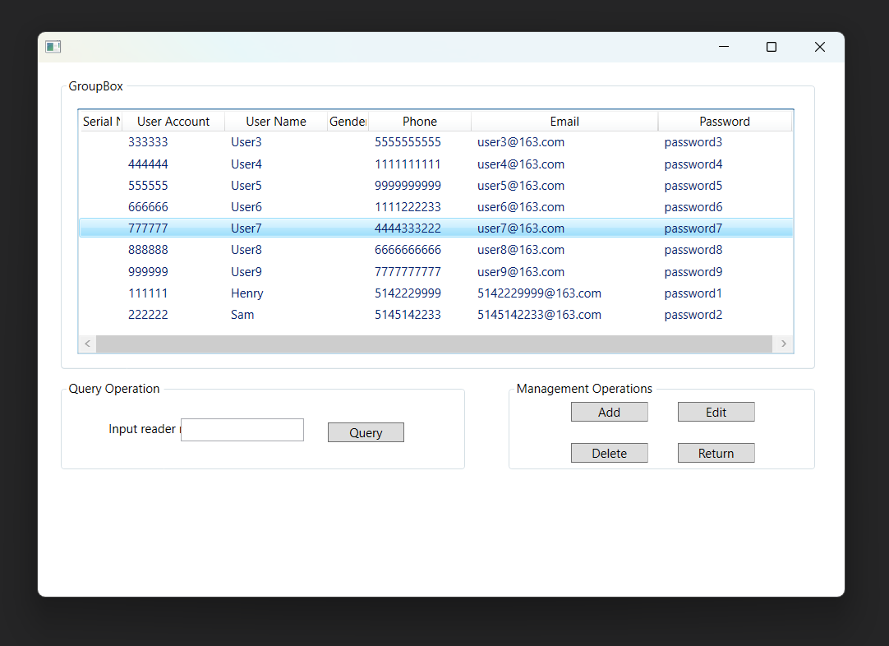

1. **Delete a user**

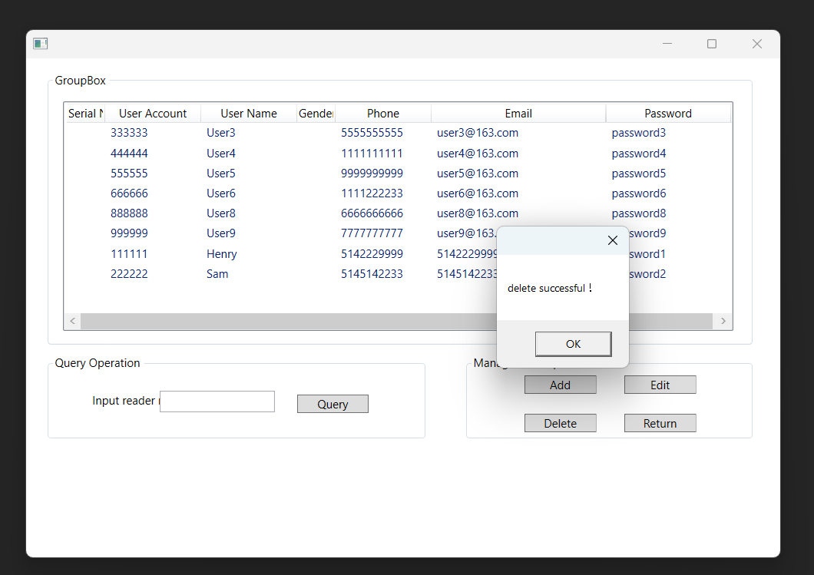

Delete a user (account id: 777777)

**REST API Integration:**

* The Reader_Borrow Class REST API communication with the database.

Query book by name of class Reader_Borrow using RestAPI

Borrow book of class Reader_Borrow using RestAPI

**3. Project Setup:**

Setup Instructions:

1. **Database Version:**
   * Utilizes PostgreSQL 15 with pgAdmin4 v6.21.
2. **Visual Studio Version:**
   * Developed using Microsoft Visual Studio 2022 version 17.7.4.
3. **.NET Framework:**
   * Built on .NET Framework 4.7.2.
4. **Rest API Snapshot:**
   * Discusses the integration of the REST API and includes relevant snapshots.

**4.Work Progress in Future:**

The College Library Management System (CLMS) has laid a solid foundation for efficient library operations, but as with any software project, there is always room for improvement and future enhancements. The following areas represent potential avenues for further development and refinement in the near future:

Enhanced Search Functionality:

The current search functionality can be further optimized to provide more accurate and intuitive results. Implementing advanced search algorithms and incorporating filters based on various criteria such as author, genre, and publication date can significantly enhance the user experience.

Make a mobile version

Consider developing a mobile application version of the CLMS to cater to users who prefer accessing library services on their mobile devices. A mobile app would provide a more convenient and accessible platform for users on the go.

Data Analytics and Reporting:

Integrate data analytics tools to gather insights into user behavior, popular book trends, and overall system usage. Implementing reporting features for administrators to analyze library statistics can contribute to data-driven decision-making.

Internationalize:

Consider adding support for multiple languages to make the CLMS accessible to a broader audience. Localization features can enhance user engagement and cater to institutions with diverse language requirements.

**Code in GitHub link:**

HTTP://github.com/yaowuvanier/AppDev-Project-YaoWu-ZhengXue.git